**Project Design Phase-II**

**Data Flow Diagram & User Stories**

|  |  |
| --- | --- |
| Date | 15 April 2025 |
| Team ID | SWTID1743695015 |
| Project Name | Shopez: E-Commerce Application |
| Maximum Marks | 4 Marks |

**Data Flow Diagram:**

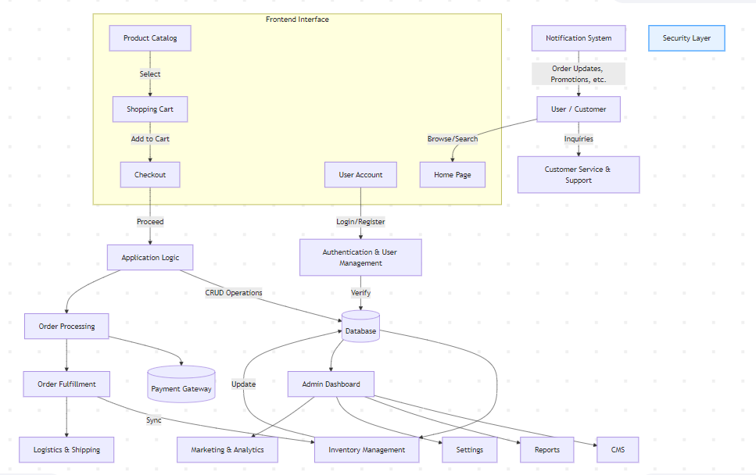

**User Stories**:

| **User Type** | **Functional Requirement (Epic)** | **User Story Number** | **User Story / Task** | **Acceptance criteria** | **Priority** | **Release** |
| --- | --- | --- | --- | --- | --- | --- |
| Customer (Mobile user) | Registration | USN-1 | As a user, I can register for the application by entering my email, password, and confirming my password. | I can access my account / dashboard | High | Sprint-1 |
|  |  | USN-2 | As a user, I will receive confirmation email once I have registered for the application | I can receive confirmation email & click confirm | High | Sprint-1 |
|  |  | USN-3 | As a user, I can register for the application through Facebook | I can register & access the dashboard with Facebook Login | Low | Sprint-2 |
|  |  | USN-4 | As a user, I can register for the application through Gmail | |  | | --- | | I can register & access  the dashboard with Gmail  Login |  |  | | --- | |  | | Medium | Sprint-1 |
|  | Login | USN-5 | As a user, I can log into the application by entering email & password | I can access my dashboard after login | High | Sprint-1 |
|  | Dashboard | USN-6 | As a user, I can view my account information and recent activity | Dashboard loads with latest activity and user profile | High | Sprint-2 |
| Customer (Web user) | Registration/Login | USN-7 | As a web user, I can register/login using email or social login | I can login or register successfully | High | |  | | --- | |  |  |  | | --- | | Sprint-2 | |
|  | Search Products | USN-8 | As a web user, I can search for products | |  | | --- | |  |  |  | | --- | | Search results are  accurate and displayed  promptly | | High | Sprint-2 |
|  | |  | | --- | |  |  |  | | --- | | Order Placement | | USN-9 | As a web user, I can place an order by adding products to the cart and making payment | Order placed successfully and confirmation received | High | |  | | --- | |  |  |  | | --- | | Sprint-3 | |
| Customer Care Executive | View Complaints | USN-10 | As a CCE, I can view complaints raised by users | Complaints load correctly with details | Medium | Sprint-3 |
|  | Respond to Complaints | USN-11 | As a CCE, I can respond to complaints with proper resolution steps | User receives response notification | |  | | --- | |  |  |  | | --- | | Medium | | |  | | --- | |  |  |  | | --- | | Sprint-3 | |
| Administrator | Manage Users | USN-12 | As an admin, I can view, edit, and delete user accounts | Admin actions reflect on user system | High | Sprint-2 |
|  | |  | | --- | |  |  |  | | --- | | Manage Products | | USN-13 | As an admin, I can add/edit/remove product listings | Product catalog updates correctly | High | Sprint-3 |
|  | View Reports | |  | | --- | |  |  |  | | --- | | USN-14 | | As an admin, I can view analytics and reports for system activity | Reports generate accurately and quickly | Medium | |  | | --- | |  |  |  | | --- | | Sprint-3 | |